Organization: Talosec
Project: Enterprise SOC Virtual Lab
Intern Name: ALI RAYYAN
Mentor: Sir Nasradin
Duration: Month 2 of Internship
Date: 27-01-2026

1. EXECUTIVE SUMMARY
This document provides a comprehensive overview of the Enterprise SOC Virtual Lab implementation completed during Month 2 of the cybersecurity internship at Talosec. The lab simulates a real enterprise environment designed for Security Operations Center (SOC) training, blue team operations, and network security architecture practice.

The lab environment includes:
- FortiGate firewall for network security and traffic control
- Windows Active Directory infrastructure for centralized authentication
- Windows workstation joined to the domain
- Ubuntu application server for internal services
- Wazuh SIEM for centralized security monitoring and log analysis

This project builds upon Month 1 activities which included Wazuh SIEM deployment, log analysis, custom detection rule creation, active response configuration, and honeypot investigation.

2. PROJECT OBJECTIVES

The primary objectives of this lab implementation were:

- Build and understand enterprise network segmentation
- Deploy and configure FortiGate firewall architecture
- Implement centralized authentication using Active Directory
- Enable endpoint and server monitoring
- Operate a SOC using Wazuh SIEM
- Practice blue team detection, logging, and alerting
- Understand trust boundaries and attack surfaces

Roles Assumed During Implementation:
- Senior Network Architect
- Virtualization Engineer
- SOC Architect
- Cybersecurity Lab Designer

3. LAB ARCHITECTURE OVERVIEW

The lab environment was built using VMware Workstation as the virtualization platform. The architecture consists of three security zones separated by a FortiGate firewall, with Wazuh SIEM providing centralized monitoring.

4. NETWORK DESIGN

4.1 Network Topology Diagram

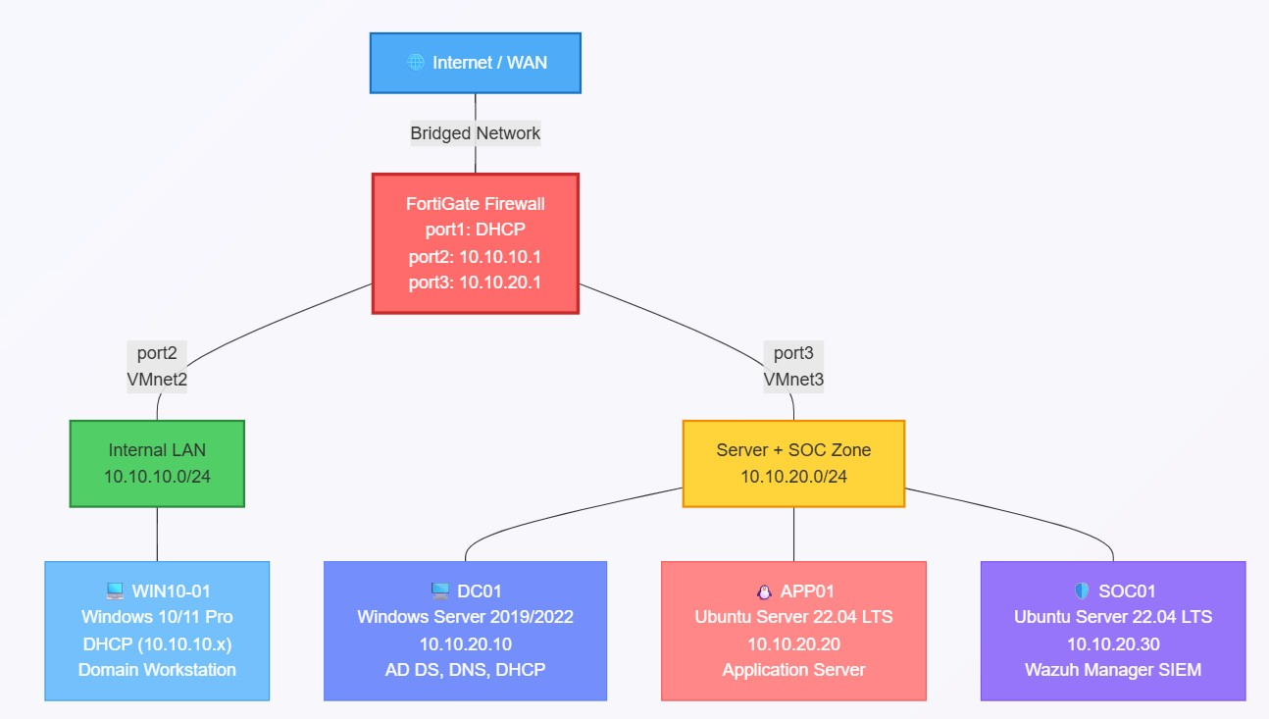
5. VM Resource Allocation:

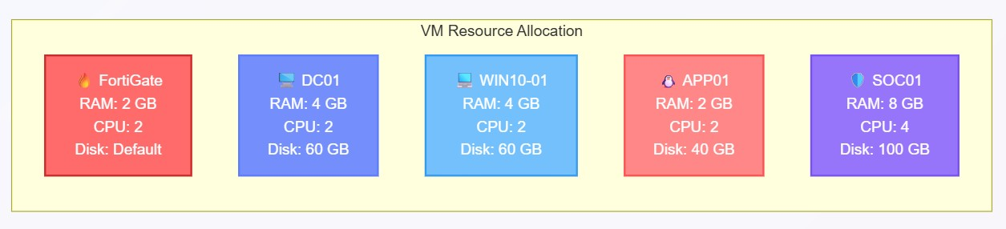
└────────────┴────────┴────────────┴───────────┘

6. IMPLEMENTATION STEPS

6.1 VMware Network Configuration
Step 1: Opened VMware Workstation and navigated to Edit → Virtual Network Editor

Step 2: Clicked "Change Settings" to run as Administrator

Step 3: Created the following virtual networks:

VMnet0 (Bridged):
- Type: Bridged
- Bridged to: WiFi Adapter
- Purpose: WAN/Internet connectivity for FortiGate

VMnet2 (Host-only):
- Type: Host-only
- Subnet: 10.10.10.0
- Subnet Mask: 255.255.255.0
- DHCP: Disabled
- Purpose: Internal LAN network

VMnet3 (Host-only):
- Type: Host-only
- Subnet: 10.10.20.0
- Subnet Mask: 255.255.255.0
- DHCP: Disabled
- Purpose: Server + SOC network

Step 4: Applied configuration and closed Virtual Network Editon
6.2 FortiGate Firewall Setup
Step 1: Imported FortiGate VM into VMware Workstation
Step 2: Configured VM hardware settings:
- Memory: 2 GB
- Processors: 2
- Network Adapter 1: VMnet0 (Bridged) - WAN
- Network Adapter 2: VMnet2 - Internal LAN
- Network Adapter 3: VMnet3 - Server + SOC

Step 3: Powered on FortiGate VM and waited for boot completion

Step 4: Logged in with default credentials:
- Username: admin
- Password: (blank)

Step 5: Set new admin password when prompted

Step 6: Configured network interfaces via CLI:

Port 1 (WAN):
─────────────
- config system interface
- edit port1
- set mode dhcp
- set allowaccess ping https ssh http fgfm
- set alias "WAN"
- set role wan
- next
- end

Port 2 (Internal LAN):
──────────────────────
- config system interface
- edit port2
- set mode static
- set ip 10.10.10.1 255.255.255.0
- set allowaccess ping https ssh http
- set alias "Internal-LAN"
- set role lan
- next
- end

Port 3 (Server + SOC):
──────────────────────
- config system interface
- edit port3
- set mode static
- set ip 10.10.20.1 255.255.255.0
- set allowaccess ping https ssh http
- set alias "Server-SOC-Network"
- set role lan
- next
- end

Step 7: Configured DNS:

- config system dns
- set primary 8.8.8.8
- set secondary 8.8.4.4
- end

Step 8: Verified interface configuration:
- get system interface physical
Step 9: Configured DHCP server for Internal LAN:

- config system dhcp server
- edit 1
- set interface "port2"
- set default-gateway 10.10.10.1
- set netmask 255.255.255.0
- set dns-server1 10.10.20.10
- set dns-server2 8.8.8.8
- config ip-range
- edit 1
- set start-ip 10.10.10.100
- set end-ip 10.10.10.200
- next
- end
- next
- end

Step 10: Tested internet connectivity:

- execute ping 8.8.8.8
- execute ping google.com
- Step 11: Configured Syslog to forward logs to Wazuh:

- config log syslogd setting
- set status enable
- set server "10.10.20.30"
- set port 514
- set facility local7
- set format default
- set mode udp
- end

- config log syslogd filter
- set severity information
- set forward-traffic enable
- set local-traffic enable
- set anomaly enable
- end

Step 12: Accessed FortiGate GUI via browser:
- URL: https://[FortiGate-WAN-IP]
- Username: admin
- Password: [configured password]

6.3 Windows Server (DC01) Setup
───────────────────────────────

Step 1: Created new VM in VMware:
- Name: DC01
- Guest OS: Windows Server 2019/2022
- Memory: 4 GB
- Processors: 2
- Disk: 60 GB
- Network: VMnet3

Step 2: Attached Windows Server ISO and started installation

Step 3: Selected "Windows Server 2019/2022 Standard (Desktop Experience)"

Step 4: Completed installation and set Administrator password: Talosec@2024!

Step 5: Configured static IP address:
- IP Address: 10.10.20.10
- Subnet Mask: 255.255.255.0
- Default Gateway: 10.10.20.1
- Preferred DNS: 127.0.0.1
- Alternate DNS: 8.8.8.8

Step 6: Tested network connectivity:

- ping 10.10.20.1
- ping 8.8.8.8

Step 7: Renamed server using PowerShell:

- Rename-Computer -NewName "DC01" -Restart

Step 8: After restart, installed Active Directory Domain Services:

- Install-WindowsFeature -Name AD-Domain-Services -IncludeManagementTools

Step 9: Promoted server to Domain Controller:

- Install-ADDSForest `
- -DomainName "talosec.local" `
- -DomainNetbiosName "TALOSEC" `
- -InstallDns:$true `
- -SafeModeAdministratorPassword (ConvertTo-SecureString "Talosec@Recovery1!" -
AsPlainText -Force) `
- -Force:$true
- Server restarted automatically.

Step 10: After restart, verified AD installation:
- Get-ADDomain
- Get-ADForest
- Get-ADDomainController
Step 11: Configured DNS forwarders:
- Add-DnsServerForwarder -IPAddress "8.8.8.8"
- Add-DnsServerForwarder -IPAddress "8.8.4.4"
Step 12: Created Organizational Units:
- New-ADOrganizationalUnit -Name "Talosec-Users" -Path "DC=talosec,DC=local"
- New-ADOrganizationalUnit -Name "Talosec-Computers" -Path "DC=talosec,DC=local"
- New-ADOrganizationalUnit -Name "Talosec-Servers" -Path "DC=talosec,DC=local"
Step 13: Created test users:

# Regular User 1
- New-ADUser -Name "John Smith" `
- -GivenName "John" `
- -Surname "Smith" `
- -SamAccountName "jsmith" `
- -UserPrincipalName "jsmith@talosec.local" `
- -Path "OU=Talosec-Users,DC=talosec,DC=local" `
- -AccountPassword (ConvertTo-SecureString "User@123" -AsPlainText -Force) `
- -PasswordNeverExpires $true `
- -Enabled $true

# Regular User 2
- New-ADUser -Name "Jane Doe" `
- -GivenName "Jane" `
- -Surname "Doe" `
- -SamAccountName "jdoe" `
- -UserPrincipalName "jdoe@talosec.local" `
- -Path "OU=Talosec-Users,DC=talosec,DC=local" `
- -AccountPassword (ConvertTo-SecureString "User@123" -AsPlainText -Force) `
- -PasswordNeverExpires $true `
- -Enabled $true

# SOC Admin User
- New-ADUser -Name "SOC Admin" `
- -GivenName "SOC" `
- -Surname "Admin" `
- -SamAccountName "socadmin" `
- -UserPrincipalName "socadmin@talosec.local" `
- -Path "OU=Talosec-Users,DC=talosec,DC=local" `
- -AccountPassword (ConvertTo-SecureString "SOCAdmin@123" -AsPlainText -Force) `
- -PasswordNeverExpires $true `
- -Enabled $true

# Add SOC Admin to Domain Admins
- Add-ADGroupMember -Identity "Domain Admins" -Members "socadmin"

Step 14: Verified users:
- Get-ADUser -Filter * -SearchBase "OU=Talosec-Users,DC=talosec,DC=local" | SelectObject Name, SamAccountName
Step 15: Enabled advanced audit policies:

- auditpol /set /subcategory:"Logon" /success:enable /failure:enable
- auditpol /set /subcategory:"Logoff" /success:enable
- auditpol /set /subcategory:"Account Lockout" /failure:enable
- auditpol /set /subcategory:"Special Logon" /success:enable
- auditpol /set /subcategory:"User Account Management" /success:enable /failure:enable
- auditpol /set /subcategory:"Security Group Management" /success:enable • auditpol /set /subcategory:"Process Creation" /success:enable

Step 16: Created snapshot - "DC01-AD-Complete"
6.4 Windows 10/11 Workstation (WIN10-01) Setup

Step 1: Created new VM in VMware:
- Name: WIN10-01
- Guest OS: Windows 10/11 x64
- Memory: 4 GB
- Processors: 2
- Disk: 60 GB
- Network: VMnet2

Step 2: Attached Windows 10/11 Pro ISO and started installation

Step 3: Completed installation with local account:
- Username: localadmin
- Password: Talosec@2024

Step 4: Verified DHCP IP assignment:

- ipconfig /all

Expected output:
- IPv4 Address: 10.10.10.100 (or similar from DHCP range)
- Subnet Mask: 255.255.255.0
- Default Gateway: 10.10.10.1
- DNS Server: 10.10.20.10
Step 5: Tested network connectivity:

ping 10.10.10.1 ping 10.10.20.10
ping 8.8.8.8 nslookup talosec.local

Step 6: Joined domain using PowerShell (Administrator):
- Add-Computer -DomainName "talosec.local" -Credential TALOSEC\Administrator Restart
- Entered password: Talosec@2024!

Step 7: After restart, tested domain login:
- Username: TALOSEC\jsmith
- Password: User@123
Login successful.
Step 8: Installed Sysmon for enhanced logging:
# Created Sysmon folder
- New-Item -Path "C:\Sysmon" -ItemType Directory -Force
# Downloaded Sysmon
- Invoke-WebRequest -Uri "https://download.sysinternals.com/files/Sysmon.zip" OutFile "C:\Sysmon\Sysmon.zip"

# Extracted files
- Expand-Archive -Path "C:\Sysmon\Sysmon.zip" -DestinationPath "C:\Sysmon" -Force

# Downloaded SwiftOnSecurity config
- Invoke-WebRequest -Uri
"https://raw.githubusercontent.com/SwiftOnSecurity/sysmonconfig/master/sysmonconfig-export.xml" -OutFile "C:\Sysmon\sysmonconfig.xml"

# Installed Sysmon with config
- C:\Sysmon\Sysmon64.exe -accepteula -i C:\Sysmon\sysmonconfig.xml

Step 9: Verified Sysmon running:
- Get-Service Sysmon64
6.5 Ubuntu Application Server (APP01) Setup

Step 1: Created new VM in VMware:
- Name: APP01
- Guest OS: Ubuntu 64-bit
- Memory: 2 GB
- Processors: 2
- Disk: 40 GB
- Network: VMnet3
Step 2: Attached Ubuntu Server 22.04 LTS ISO and started installation

Step 3: Completed installation:
- Server name: APP01
- Username: sysadmin
- Password: Talosec@2024
- Enabled OpenSSH server during installation
Step 4: Logged in and configured static IP:
- sudo nano /etc/netplan/00-installer-config.yaml
Content: network:
version: 2 renderer: networkd ethernets: ens33: addresses: - 10.10.20.20/24 routes: - to: default via: 10.10.20.1 nameservers: addresses:
    - 10.10.20.10 - 8.8.8.8 search:
    - talosec.local
Step 5: Applied network configuration: • sudo netplan apply
Step 6: Verified network configuration:

- ip addr show
- ping 10.10.20.1
- ping 8.8.8.8
Step 7: Set hostname:

- sudo hostnamectl set-hostname APP01

Step 8: Updated system:

- sudo apt update && sudo apt upgrade -y

Step 9: Installed Apache web server:

- sudo apt install apache2 -y
- sudo systemctl enable apache2
- sudo systemctl start apache2

Step 10: Created test web page:

sudo bash -c 'cat > /var/www/html/index.html << EOF
<!DOCTYPE html>
<html>
<head>
<title>Talosec Internal Server</title>
</head>
<body>
<h1>Welcome to Talosec Internal Application Server</h1>
<p>Server: APP01</p>
<p>IP: 10.10.20.20</p>
</body>
</html>
EOF'

Step 11: Verified Apache running:

- sudo systemctl status apache2
- curl http://localhost

Step 12: Installed audit daemon:

- sudo apt install auditd audispd-plugins -y
- sudo systemctl enable auditd
- sudo systemctl start auditd

Step 13: Created snapshot - "APP01-Configured"

6.6 Wazuh Manager (SOC01) Setup

Step 1: Created new VM in VMware:
- Name: SOC01
- Guest OS: Ubuntu 64-bit
- Memory: 8 GB (Important for Wazuh)
- Processors: 4
- Disk: 100 GB
- Network: VMnet3

Step 2: Attached Ubuntu Server 22.04 LTS ISO and started installation

Step 3: Completed installation:
- Server name: SOC01
- Username: socadmin
- Password: Talosec@2024
- Enabled OpenSSH server during installation

Step 4: Logged in and configured static IP:

sudo nano /etc/netplan/00-installer-config.yaml

Content: network:
version: 2 renderer: networkd ethernets: ens33: addresses:
    - 10.10.20.30/24
routes: - to: default via: 10.10.20.1 nameservers: addresses:
    - 10.10.20.10 - 8.8.8.8 search:
    - talosec.local

Step 5: Applied network configuration:

sudo netplan apply

Step 6: Verified connectivity:

- ip addr show
- ping 10.10.20.1
- ping 10.10.20.10
- ping 8.8.8.8

Step 7: Set hostname:

- sudo hostnamectl set-hostname SOC01

Step 8: Updated system:

sudo apt update && sudo apt upgrade -y

Step 9: Installed Wazuh (All-in-One installation):

- curl -sO https://packages.wazuh.com/4.7/wazuh-install.sh
- sudo bash wazuh-install.sh -a

Installation took approximately 15-20 minutes.

Step 10: Saved admin password displayed at end of installation

Note: Password was saved from installation output for dashboard access.

Step 11: Verified Wazuh services:

- sudo systemctl status wazuh-manager
- sudo systemctl status wazuh-indexer
- sudo systemctl status wazuh-dashboard

All three services showed "active (running)" status.
Step 12: Accessed Wazuh Dashboard:

URL: https://10.10.20.30
Username: admin
Password: [password from installation]

Accepted certificate warning and logged in successfully.
Step 13: Configured Wazuh to receive syslog from FortiGate:

sudo nano /var/ossec/etc/ossec.conf

Added the following within <ossec_config>:
<remote>
<connection>syslog</connection>
<port>514</port>
<protocol>udp</protocol>
<allowed-ips>10.10.20.1</allowed-ips>
</remote>

Step 14: Restarted Wazuh Manager:

sudo systemctl restart wazuh-manager

6.7 Wazuh Agent Deployment

6.7.1 Agent on DC01 (Windows Server)

Step 1: In Wazuh Dashboard, navigated to Agents → Deploy new agent

Step 2: Selected:
- Operating System: Windows
- Server address: 10.10.20.30
- Agent name: DC01

Step 3: On DC01, opened PowerShell as Administrator and ran:

Invoke-WebRequest -Uri https://packages.wazuh.com/4.x/windows/wazuh-agent-4.7.01.msi -OutFile ${env:tmp}\wazuh-agent.msi; msiexec.exe /i ${env:tmp}\wazuh-agent.msi /q
WAZUH_MANAGER='10.10.20.30' WAZUH_AGENT_NAME='DC01'
WAZUH_REGISTRATION_SERVER='10.10.20.30'
Step 4: Started the agent service:

NET START Wazuh

Step 5: Verified agent running:
Get-Service Wazuh

6.7.2 Agent on WIN10-01 (Windows Workstation)

Step 1: On WIN10-01, opened PowerShell as Administrator and ran:

Invoke-WebRequest -Uri https://packages.wazuh.com/4.x/windows/wazuh-agent-4.7.01.msi -OutFile ${env:tmp}\wazuh-agent.msi; msiexec.exe /i ${env:tmp}\wazuh-agent.msi /q
WAZUH_MANAGER='10.10.20.30' WAZUH_AGENT_NAME='WIN10-01'
WAZUH_REGISTRATION_SERVER='10.10.20.30'

Step 2: Started the agent service:

NET START Wazuh

Step 3: Verified agent running:

Get-Service Wazuh
6.7.3 Agent on APP01 (Ubuntu Server)
Step 1: Added Wazuh repository:
curl -s https://packages.wazuh.com/key/GPG-KEY-WAZUH | gpg --no-default-keyring -keyring gnupg-ring:/usr/share/keyrings/wazuh.gpg --import && chmod 644
/usr/share/keyrings/wazuh.gpg
echo "deb [signed-by=/usr/share/keyrings/wazuh.gpg] https://packages.wazuh.com/4.x/apt/ stable main" | sudo tee -a /etc/apt/sources.list.d/wazuh.list

sudo apt update

Step 2: Installed agent:

- sudo WAZUH_MANAGER='10.10.20.30' WAZUH_AGENT_NAME='APP01' apt install wazuh-agent -y

Step 3: Enabled and started agent:
- sudo systemctl daemon-reload
- sudo systemctl enable wazuh-agent
- sudo systemctl start wazuh-agent
Step 4: Verified agent running:
- sudo systemctl status wazuh-agent
6.7.4 Verified All Agents in Wazuh Dashboard

Navigated to Wazuh Dashboard → Agents and verified all three agents showing "Active" status:
- DC01 - Active
- WIN10-01 - Active
- APP01 - Active

7. FIREWALL POLICIES

Three firewall policies were created on FortiGate to control traffic between zones:
7.1 Policy Summary

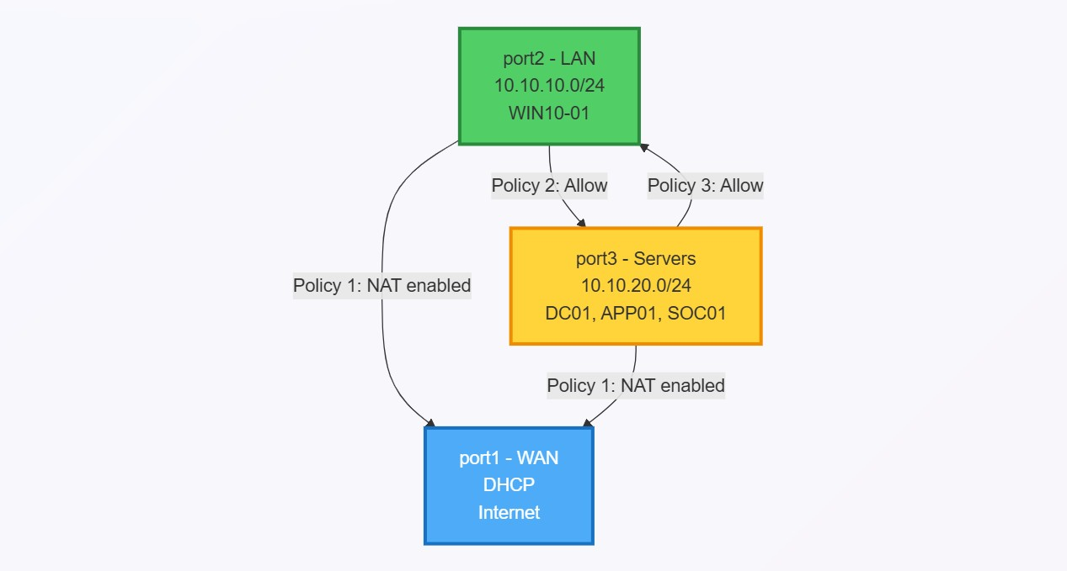
7.2 Policy Configurations

Policy 1: All-to-Internet

Purpose: Allows all internal networks to access the internet

- config firewall policy
- edit 1
- set name "All-to-Internet"
- set srcintf "port2" "port3"
- set dstintf "port1"
- set srcaddr "all"
- set dstaddr "all"
- set action accept
- set schedule "always"
- set service "ALL"
- set nat enable
- set logtraffic all
- next
- end

Policy 2: LAN-to-Servers
Purpose: Allows workstations to access servers and SIEM

- config firewall policy
- edit 2
- set name "LAN-to-Servers"
- set srcintf "port2"
- set dstintf "port3"
- set srcaddr "all"
- set dstaddr "all"
- set action accept
- set schedule "always"
- set service "ALL"
- set logtraffic all
- next
- end

Policy 3: Servers-to-LAN
Purpose: Allows servers to respond to LAN (required for DHCP, DNS responses)

- config firewall policy
- edit 3
- set name "Servers-to-LAN"
- set srcintf "port3"
- set dstintf "port2"
- set srcaddr "all"
- set dstaddr "all"
- set action accept
- set schedule "always"
- set service "ALL"
- set logtraffic all
- next
- end

7.3 Traffic Flow Diagram
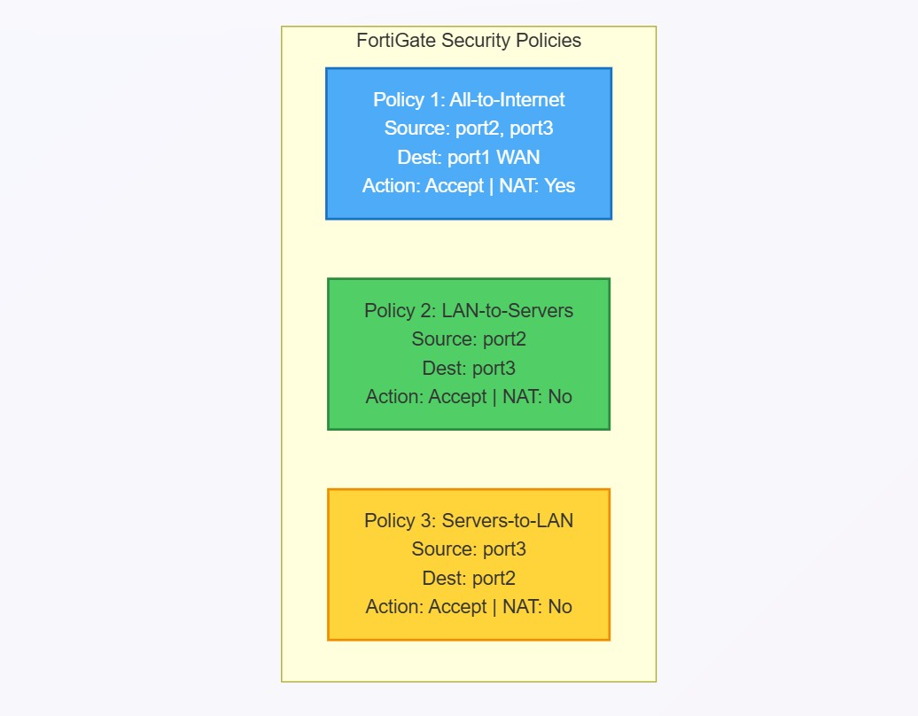

8. TESTING AND VALIDATION

8.1 Network Connectivity Tests

Test 1: WIN10-01 to FortiGate Gateway
Command: ping 10.10.10.1
Result: Success - 4 packets sent, 4 received

Test 2: WIN10-01 to DC01
Command: ping 10.10.20.10
Result: Success - 4 packets sent, 4 received

Test 3: WIN10-01 to Internet
Command: ping 8.8.8.8
Result: Success - 4 packets sent, 4 received

Test 4: WIN10-01 DNS Resolution
Command: nslookup talosec.local
Result: Success - Resolved to 10.10.20.10

Test 5: DC01 to FortiGate Gateway
Command: ping 10.10.20.1
Result: Success - 4 packets sent, 4 received

Test 6: DC01 to Internet
Command: ping 8.8.8.8
Result: Success - 4 packets sent, 4 received
8.2 Security Event Testing

8.2.1 Failed Login Attempts Test

Objective: Generate failed login attempts and verify detection in Wazuh SIEM

Step 1: On WIN10-01, logged out of current session

Step 2: Attempted login with incorrect password:
- Username: TALOSEC\jsmith
- Password: WrongPassword123 (incorrect)

Step 3: Repeated failed login attempt 5 times

Step 4: Verified in Wazuh Dashboard:
- Navigated to Security Events
- Filtered by agent: WIN10-01
- Found alerts for "Authentication failure" (Rule ID: 60122)
Detection Details:
- Rule ID: 60122
- Rule Description: Windows logon failure
- MITRE ATT&CK: T1110 - Brute Force
- Agent: WIN10-01
- Number of Alerts: 5

8.2.2 Successful Login Test
───────────────────────────

Objective: Verify successful login is logged and visible in Wazuh

Step 1: On WIN10-01, logged in with correct credentials:
- Username: TALOSEC\jsmith
- Password: User@123

Step 2: Login was successful

Step 3: Verified in Wazuh Dashboard:
- Navigated to Security Events
- Filtered by agent: WIN10-01
- Found event for "Successful logon" (Rule ID: 60101)
Detection Details:
- Rule ID: 60101
- Rule Description: Windows logon success
- Agent: WIN10-01
- Logon Type: Interactive

8.3 Test Summary
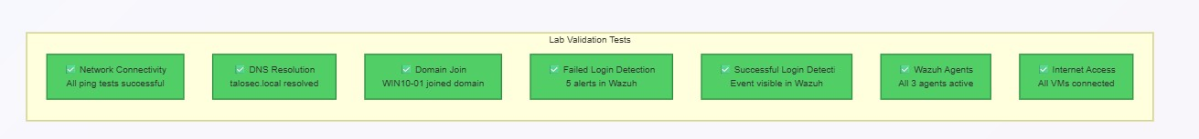

9. Challenges and Solutions
Problem
Originally planned for 4-port architecture but FortiGate VM only recognized 3 network adapters.
Solution
Modified lab design to use 3-port architecture by combining Server Network and SOC Network into a single zone (10.10.20.0/24). This simplified the design while maintaining security monitoring capabilities.

Problem
FortiGate GUI showed license evaluation page that kept buffering

Root Cause:
FortiGate could not reach FortiGuard license servers

Solution:
Configured proper WAN interface with DHCP and ensured internet connectivity. Proceeded with evaluation mode for lab purposes.

Problem:
FortiGate GUI showed license evaluation page that kept buffering

Root Cause:
FortiGate could not reach FortiGuard license servers

Solution
Configured proper WAN interface with DHCP and ensured internet connectivity. Proceeded with evaluation mode for lab purposes

10. Lessons Leart

1. NETWORK SECURITY FUNDAMENTALS

1.1 Network Segmentation
Learned the importance of dividing networks into separate security zones to:
• Limit the blast radius of potential security breaches
• Control traffic flow between different trust levels
• Implement the principle of least privilege at the network level
• Create clear security boundaries between users, servers, and management systems

Practical Understanding:
• WAN zone (Untrusted) - External internet connectivity
• LAN zone (Medium Trust) - User workstations
• Server/SOC zone (High Trust) - Critical infrastructure and security tools

1.2 Defense in Depth

Understood the concept of layered security by implementing:
• Perimeter security (FortiGate Firewall)
• Network segmentation (VLANs/Subnets)
• Endpoint monitoring (Wazuh Agents)
• Centralized logging (Wazuh SIEM)

2. FORTIGATE FIREWALL SKILLS

2.1 Firewall Architecture
Learned how enterprise firewalls function as:
• Network gateway controlling traffic between zones
• Policy enforcement point for security rules
• NAT device for internet connectivity
• Logging source for security monitoring
• DHCP server/relay for IP address management

2.2 Interface Configuration
Gained hands-on experience configuring:
• WAN interface with DHCP for internet connectivity
• LAN interfaces with static IP addressing
• Interface aliases for easy identification
• Access control (ping, HTTPS, SSH, HTTP) per interface
• Interface roles (WAN vs LAN) for policy automation

2.3 Firewall Policy Management
Learned to create and manage firewall policies including:
• Source and destination zone selection
• Address object creation and management
• Service and port configuration
• Policy actions (Accept, Deny)
• NAT configuration for internet-bound traffic
• Traffic logging for security visibility
• Policy ordering and rule precedence
Key Insight: Firewall policies are processed top-to-bottom, and the order of
rules matter significantly for both security and functionality.

2.4 Syslog Integration
Configured FortiGate to forward logs to external SIEM:
• Syslog server configuration
• Log filtering and severity levels
• UDP protocol for log transmission
• Facility and format settings

3. WINDOWS SERVER ADMINISTRATION

3.1 Active Directory Domain Services

Gained practical experience with:
• AD DS role installation and configuration
• Domain controller promotion
• Forest and domain creation
• Organizational Unit (OU) structure design
• User and group management
• Security group membership

3.2 DNS Server Management

Learned DNS concepts and configuration:
• DNS role integration with Active Directory
• Forward lookup zone management
• DNS forwarder configuration for external resolution
• Importance of DNS in domain environments
• Troubleshooting DNS resolution issues

3.3 DHCP Configuration

Understood DHCP in enterprise environments:
• DHCP scope creation and management
• IP range configuration
• Gateway and DNS option assignment
• DHCP relay concepts for cross-subnet functionality

3.4 Windows Security Logging

Configured enhanced security auditing:
• Audit policy configuration using auditpol
• Logon/logoff event tracking
• Account management auditing
• Process creation monitoring
• Understanding Windows Event IDs for security events

4. SIEM AND SECURITY MONITORING

4.1 Wazuh SIEM Architecture

Gained deeper understanding of Wazuh components:
• Wazuh Manager - Central processing and rule engine
• Wazuh Indexer - Log storage and search (OpenSearch)
• Wazuh Dashboard - Visualization and analysis interface
• Wazuh Agents - Endpoint data collection

4.2 Agent Deployment

Learned to deploy agents across different platforms:
• Windows agent installation via PowerShell
• Linux agent installation via package manager
• Agent registration and authentication
• Agent-manager communication (ports 1514, 1515, 55000)

4.3 Log Collection and Correlation

Understood how SIEM collects and correlates:
• Windows Security Event Logs
• Linux syslog and auth.log
• Firewall traffic and event logs
• Application-specific logs
• Cross-source event correlation

4.4 Security Event Detection

Observed real-time detection of:
• Failed authentication attempts (brute force indicators)
• Successful logon events
• Network traffic patterns
• Firewall allow/deny decisions

5. VIRTUALIZATION SKILLS

5.1 VMware Workstation

Developed proficiency in:
• Virtual machine creation and configuration
• Resource allocation (CPU, RAM, Disk)
• Virtual network adapter management
• Snapshot creation for backup and recovery
• VM settings optimization

5.2 Virtual Networking

Learned to configure VMware virtual networks:
• Bridged networking for external connectivity
• Host-only networking for isolated lab segments
• Virtual switch configuration
• Network adapter assignment to VMs
• Troubleshooting virtual network connectivity

6. SECURITY ARCHITECTURE CONCEPTS

6.1 Trust Zones and Boundaries

Understood the concept of trust levels:
• Untrusted (Internet/WAN) - No inherent trust
• Semi-trusted (User LAN) - Verified but limited access
• Trusted (Server/SOC) - Critical assets, restricted access

6.2 Traffic Flow Control

Learned how firewalls control traffic:
• East-West traffic (between internal zones)
• North-South traffic (to/from internet)
• Default deny philosophy
• Explicit allow rules for required communication

6.3 Centralized vs Distributed Security

Understood the benefits of centralized security monitoring:
• Single pane of glass visibility
• Correlation across multiple sources
• Centralized alerting and response
• Unified logging and retention

11. CONCLUSION

The Enterprise SOC Virtual Lab was successfully implemented, providing a comprehensive environment for cybersecurity training and blue team operations. The lab demonstrates:

Key Accomplishments:
- Successfully deployed multi-zone network architecture with FortiGate firewall
- Implemented Windows Active Directory infrastructure for centralized authentication
- Deployed Wazuh SIEM with agents across all endpoints
- Created and tested firewall policies for traffic control
- Validated security monitoring through failed and successful login detection • Established end-to-end logging pipeline from endpoints to SIEM

Skills Developed:
- Network segmentation and security zone design
- FortiGate firewall configuration and policy management
- Windows Server administration and Active Directory
- SIEM deployment and agent management
- Security event analysis and investigation
- Virtualization and lab environment design
- Troubleshooting network connectivity issues

This lab provides a solid foundation for:
- SOC Analyst training
- Blue team exercises
- Security architecture understanding
- Incident detection and response practice

The experience gained from building this environment, including troubleshooting various networking and configuration challenges, has significantly enhanced practical cybersecurity skills applicable to real-world enterprise environments.

12. REFERENCES

- FortiGate Administration Guide https://docs.fortinet.com/

- Wazuh Documentation https://documentation.wazuh.com/

- Microsoft Active Directory Documentation https://docs.microsoft.com/en-us/windows-server/identity/ad-ds/

- VMware Workstation Documentation https://docs.vmware.com/en/VMware-Workstation-Pro/

- Sysmon Configuration by SwiftOnSecurity https://github.com/SwiftOnSecurity/sysmon-config

Appendix A: Quick Reference - IP Addresses
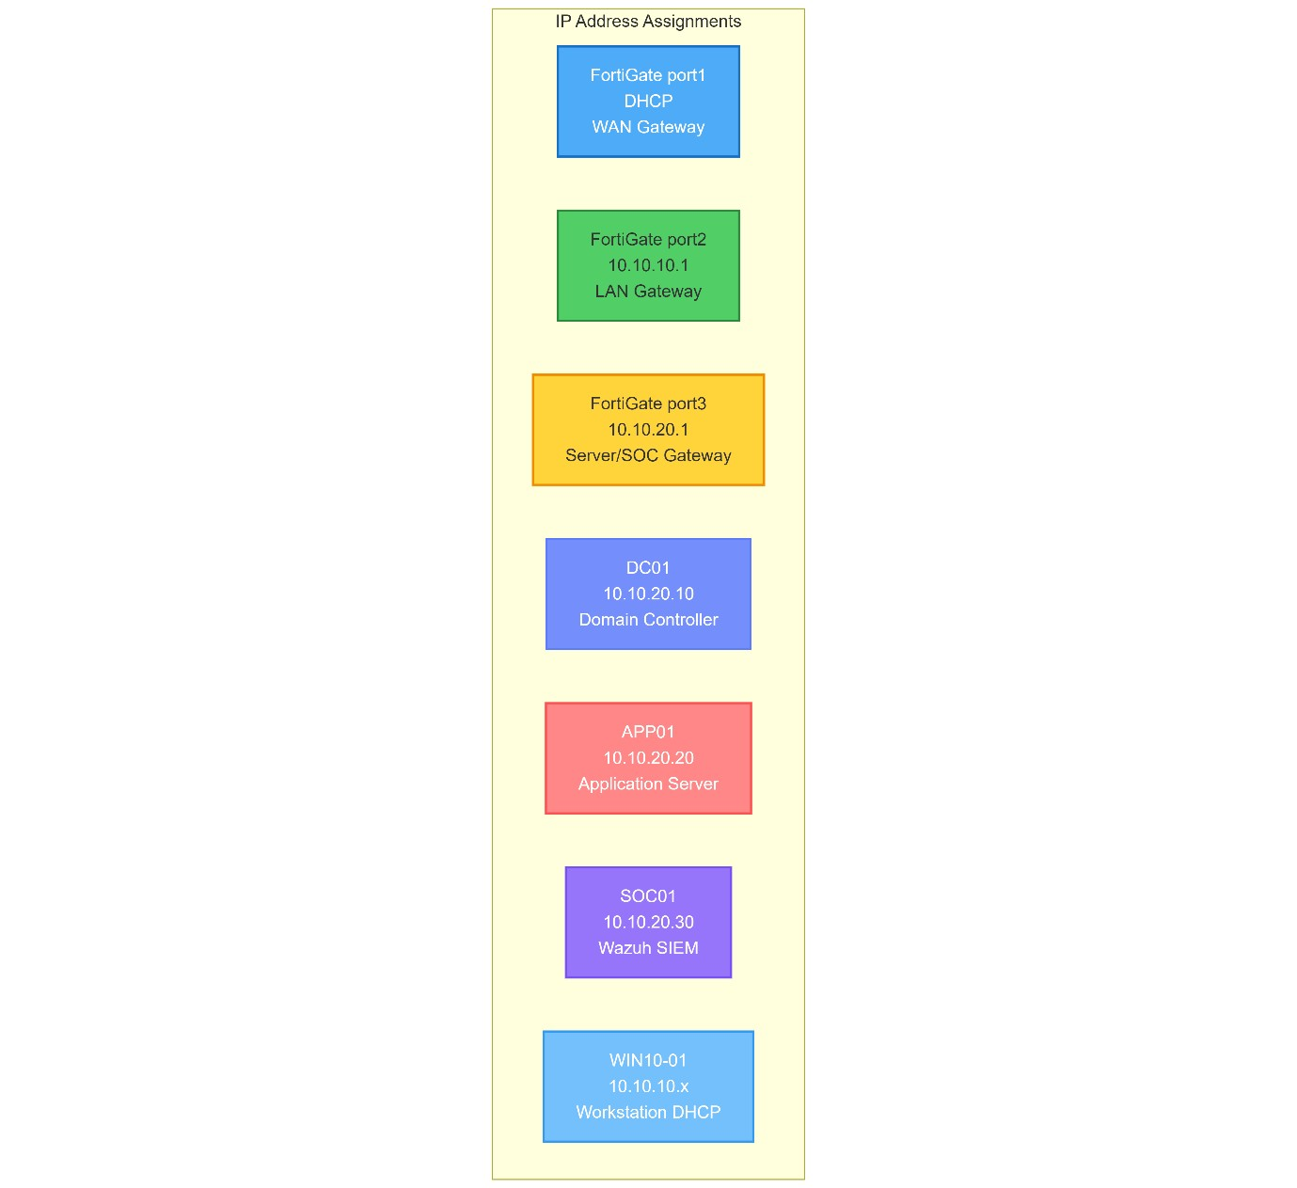

Appendix B: Quick Reference - Credentials
